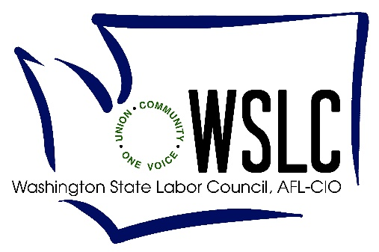
April 22, 2019

Re: Healthcare Worker Meal and Rest Breaks

Dear Honorable Members of the Washington State House and Senate:
We are writing you today to express our firm support for the nurses, nursing assistants, surgical technologists, and other front-line hospital workers who are trying to achieve the most basic of workers’ rights – access to uninterrupted meal and rest breaks, and basic protections against abusive, unmitigated mandatory overtime.
Workers in healthcare settings work demanding, physical jobs, and provide critical care to us and our families during some of the most challenging times of our lives. In emergency rooms and intensive care units, in cancer wards and in psychiatric care, these workers take care of us and our loved ones when we are vulnerable. The fact that these workers are denied practical access to meal and rest breaks, and are regularly forced to work overtime, is shameful. And it is unbelievable that it is such a challenge to protect these workers who have done so much for the rest of us when so many other states have secured these protections.
When you consider further versions of this policy, we ask that you reject efforts to deny workers at Critical Access Hospitals these basic rights. You should further reject efforts to deny non-nursing, front line staff these rights as well. Of the twenty states who have adopted similar protections for healthcare workers, none of them punish workers in Critical Access Hospital or rural settings, and techs working alongside nursing staff and under the same conditions cannot be treated as though they are less valid than nurses. We should not be the first state to say that some rural workers, patients and communities matter less than others. Whether we are seeking care at our community hospital, or in another community as we are passing through, we need to know that those workers providing our care are as rested, and respected, as we expect ourselves to be at our own workplaces.
As we face our own mortality, or when we welcome our children in to this world, we need our caregivers to be rested and performing their critical work at the best of their ability every time. As patients, during surgeries, during the examination of an x-ray, during a challenging pregnancy’s difficult delivery, or during a crisis in an emergency room, our lives are at risk. As tax payers who support these hospitals, we expect our investment to provide the best possible care. As residents of this State, it’s scary to see hospital employers working so hard to deny so many such basic rights.
Please do the right thing, and pass a healthcare worker break and overtime bill that honors and respects the workers who do so much for the rest of us. Reject efforts to amend the bill that treats one set of workers differently than their coworkers, and ensure that all healthcare workers, in all hospitals – rural and urban – are treated with dignity and respect.
Thank you for your consideration.

21 Progress  American Federation of Teachers, Washington  Philip Randolph Institute  Asian Pacific American Labor Alliance  Casa Latina  Church Council of Greater Seattle  Community Alliance for Global Justice  Economic Opportunity Institute  Faith Action Network  Got Green  International Association of Machinists, 751  International Brotherhood of Electrical Workers, 77  International Union of Operating Engineers, 302  International Union of Painters & Allied Trades, District Council 5  Ironworkers, 86  Jobs with Justice, Whatcom County  Legal Voice  Kitsap County Central Labor Council, AFL-CIO  LGBTQ Allyship  LELO: Legacy of Equality, Leadership, & Organizing  MomsRising  National Organization for Women (NOW), Seattle Chapter  North-West Health Law Advocates  North-West Washington Central Labor Council, AFL-CIO  OneAmerica  Pacific Northwest Regional Council of Carpenters  Partnering with Youth Achievement  Pride at Work  Protec 17  Puget Sound Advocates for Retirement Action  Real Change  Retired Public Employees Council, Washington  San Juan County Democrats  Service Employees International Union, 775  Service Employees International Union, 925  Service Employees International Union, 1199NW  Skagit County Labor Democrats Workgroup  SMART/UTU  State Wide Poverty Action Network  Tacoma Ministerial Alliance  Teamsters, Joint Council 28  Teamsters, 117  Teamsters, 231  Teamsters, 690  Teamsters, 760  Teamsters, 763  Teamsters, 839  Thurston-Lewis-Mason Counties Central Labor Council, AFL-CIO  Transit Riders Union  Unemployment Law Project  United Food and Commercial Workers, 21 | Washington Education Association  Washington Federation of State Employees, AFSCME Council 28  Washington Public Employees Association, UFCW 365  Washington State Association for Justice  Washington State Alliance for Retired Americans  Washington State Building and Construction Trades Council  Washington State Coalition Against Domestic Violence  Washington State Command Council/ National Association for Black Veterans  Washington State Council of County and City Employees, AFSCME Council 2  Washington State Council of Fire Fighters  46 Everett Firefighters  404 Walla Walla  437 Bremerton  469 Yakima  864 Renton Firefighters  876 Spokane Valley  1052 Richland, Prosser, West Richland,  1258 Moses Lake  1296 Kennewick  1433 Pasco  1537 Anacortes Firefighters  1760 Shoreline Firefighters  1828 South Snohomish County Union Firefighters  1892 Pullman  1919 Cheney  2299 Clarkson  2459 Northshore Firefighters  2819 Kitsap County Firefighters  2916 Spokane Co Fire district 9 & 10  2933 Clallam County Firefighters (Sequim)  3542 Sunnyside  3701 Spokane Valley Chiefs  3711 Spokane County District 8  3829 Dupont Firefighters  3916 Granite Falls Firefighters  4333 Stevens County  4418 Grant County Professional Firefighter  4965 Tri-County Firefighters (Franklin #3, Walla Walla #5)  5133 Whidbey Paramedics  5134 Cascade Paramedics (Leavenworth)  I-24 Hanford Firefighters, Benton #2  Washington State Labor Council  Washington State Nurses Association  Working Washington/Fair Work Center

